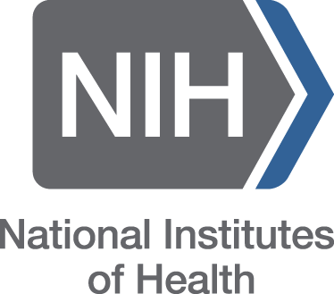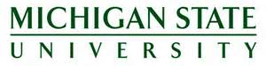**Quantitative Microbial Risk Assessment Interdisciplinary Instructional Institute**

**August 1-12, 2015** Michigan State University

Funded by National Institutes of Health

The Quantitative Microbial Risk Assessment Interdisciplinary Instructional Institute (QMRA III) will be held at Michigan State University. Participants will learn how to use scientific data and computer programs toward building a risk assessment for assuring safety and health goals. QMRA III is designed for advanced graduate students, post-doctoral fellows and early-career professionals. Participants will gain hands-on experience with risk assessment software and work on real-world case studies.

QMRA III is a 10 day workshop, where participants will (1) attend lectures from the top scientists in the QMRA field; (2) engage in specific hands-on exercises; (3) under the mentorship of a program faculty member and teaching assistant, conduct a QMRA as a research case study within a multidisciplinary team; and (4) use and contribute to the QMRAwiki (http://qmrawiki.canr.msu.edu/). We assume no prior computational experience on the part of the participants. Therefore, we will include tutorials in computer models and applications for risk assessment.

**Registration Information and Program Contact**

<http://agbioresearch.msu.edu/researcher_resources/microbial_risk_assessment_training>

Dr. Jade Mitchell or Dr. Mark Weir at [QMRAIII@anr.msu.edu](mailto:QMRAIII@anr.msu.edu)

*The QMRA III is supported by the National Institute Of General Medical Sciences of the National Institutes of Health under Award Number R25GM108593. The content is solely the responsibility of the QMRA III program directors and does not necessarily represent the official views of the National Institutes of Health.*

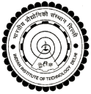

**International Perspectives on Quantitative Microbial Risk Assessment**

**March 23-27, 2015** IIPH Hyderabad, Hyderabad, India

or

**June 7-12, 2015** Drexel University, Philadelphia, USA

Funded by Obama-Singh Initiative

This workshop will be jointly taught by Drexel faculty and visiting faculty from the Indian Institute of Technology at Delhi, the Indian Institute of Public Health Hyderabad, and India’s National Environmental Engineering Research Institute. Participants will learn the tools and skills to quantitatively assess microbial risks to human health associated with global water, air, and food quality challenges. Participants will gain hands-on experience with risk assessment software and work on real-world case studies.

**Program Contact**

Questions or requests for application materials and travel support,

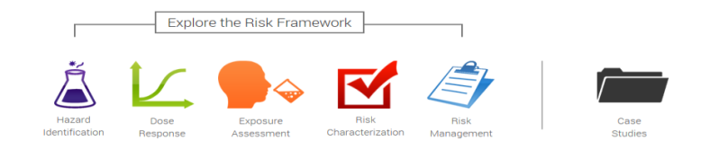

For March course in India: Dr. Arun Kumar at [arunku@civil.iitd.ac.in](mailto:arunku@civil.iitd.ac.in)

For June course in USA: Dr. Patrick Gurian at pgurian@drexel.edu